

DOD/CDAO OVL
Operation Vulcan Logic (OVL) Guide
AO Determination Brief
V2.0
July 2024

Point of Contact for this document:
osd.ncr.cdao.mbx.ovl@mail.mil

Version History
REVISION AND HISTORY PAGE: Revisions and version changes to this document are recorded within the following table. New versions are published when changes to the document equate to 10 percent or greater of the document’s content or if a change requires immediate implementation. This record is maintained throughout the life of the document.

This document will be reviewed at a minimum annually.

Date | Version | Change Type | Modified By
18 Dec 2023 | V1.0 | Initial Version | Arlo Solutions
11 July 2024 | V2.0 | Updated for CDAO | Arlo Solutions

Table of Contents
Version History 1
Table of Contents 2
1. Risk Assessment Process Overview 4
1.1 Introduction 4
1.2 Objective 4
1.3 Applicability and Scope 4
1.4 AO Confidence Levels 5
2. Assessments 6
2.1 Threat Assessment 6
2.2 Vulnerability Assessment 6
2.3 Risk Assessment 6
3. AO Determination Briefing 7
3.1 Slide Instructions 7
3.2 Title Slide 8
3.3 Program and AO Team 9
3.4 Bottom Line Up Front (BLUF) 10
3.5 Mission and System Description 12
3.6 Cybersecurity and Resilience Enablers 13
3.7 Supply Chain Risks 14
3.8 System Architecture 16
3.9 Interconnections and Interfaces 17
3.10 Authorization Boundary 18
Authorization Boundary Continued 19
Mission Partners 20
3.11 Cyber Tech Order and Continuous Monitoring 21
3.12 CDAO ORTB 22
3.13 CDAO ORTB – AI View 23
3.14 Risk Assessment Model 25
3.15 Assessment Approach 27
3.16 Cyber Test Schedule 30
3.17 PenTest Schedule 31
3.18 Risk Scale Summary 32
3.19 Risk Analysis Report 33
3.20 Mitigating Factors 34
3.21 Summary 35
3.22 Backup Slides 36
3.23 Impact Level Comparison 37
3.24 Cloud System Architecture 38
3.25 Cloud Data Flow Diagram 39
3.26 Cloud Authorization Boundary 40
3.27 Cybersecurity Service Provider (CSSP) or Equivalent Services 41
3.28 Equivalent CSSP Services 42
3.29 OVL Authorization Package 43
3.30 SAP Protection Levels 44
3.31 SAP Body of Evidence 46
3.32 SAP Connection Package Required Documentation 47
3.33 SAP ORTB 48
3.34 SAP ORTB (Continued) 51
3.35 Additional DAF Back-Up Slides 54
eMASS Guidance AFI 17-101 54
OVL AO eMASS Guidance 55
Authorization Package 56
Authorization Determination Table 56

Risk Assessment Process Overview

Introduction
The Authorizing Official (AO) has been appointed to issue determinations information technology (IT), including information systems (IS); Platform IT (PIT); IT services; IT products; IT applications; Research, Development, Test, and Evaluation (RDT&E); Cloud IS services; and products requiring agile acquisition. The AO issues determinations based on the confidence in the actual risk levels and information presented. Program Management Offices (PMOs) are expected to conduct assessments of the IT within their purview, document results in a determination briefing, and present the information to the AO so a risk determination can be made and an operational determination issued.

Objective
The objective of this guide is to assist program personnel in understanding what the AO expects to make an informed risk determination. This includes but is not limited to the PMO recognizing threats, identifying internal and external vulnerabilities, understanding the impact of vulnerabilities being exploited, likelihood of occurrence, the identification of risks, remediation actions to eliminate risk, and mitigation strategies to lower risk to an acceptable level.

Program Managers (PMs) are fully expected to own the Assessment and Authorization (A&A) process for the systems within their purview. The AO requests that PMs present the determination briefing when requesting an authorization determination. All artifacts, test results, and related documentations are expected to be thoroughly reviewed and understood by the PM, and any vulnerabilities or items requiring any sort of mitigation must be included in an updated Plan of Action and Milestones (POA&M) prior to briefing the AO.

Applicability and Scope
This guide is applicable to organizations that develop and/or maintain information systems, Cloud information systems, PIT, IT applications, products, services, RDT&E, and agile acquisition. The scope of this guide is limited to providing guidance for developing determination briefings to receive authorization determination.

This guide is intended for an audience familiar with NIST 800-series Special Publications; experienced with threat/vulnerability pairing, conducting risk and vulnerability assessments, and understanding the output of such assessments; and experienced with implementing remediation actions and/or mitigation strategies.

AO Confidence Levels
The AO expects to be fully informed of a program’s security posture and will make risk determinations based on the confidence in the information presented. A typical program would have completed the assessments in Section 2 below, had independent assessments conducted (including but not limited to penetration and/or vulnerability testing, verification testing, developmental/operational testing, Control Risk Assessor (CRA) assessments, etc.), and documented the results in the determination briefing prior to requesting the AO make a risk-based determination. The higher level of involvement by the PM and the more assessments conducted to truly understand the security posture will lead to a higher level of confidence in the determination made by the AO, typically resulting in a longer authorization period.

The Risk Scale Summary is expected to be used to determine a residual risk based on available artifacts, documentation, and completed actions. The completed Risk Analysis report will be made available to the AO as part of the determination briefing. The AO reserves the right to determine the final risk based on evidence presented. Note: Evidence will result in an overall LOW confidence level if it is not presented, completed, and/or inaccurate, and the conclusion may be determined as HIGH Risk.

Assessments

Threat Assessment
Threat assessment is the practice of determining the credibility and seriousness of a potential threat as well as the probability that the threat will become a reality. A threat assessment is the process of identifying and formally evaluating the degree of threats to information technology and describing the nature of the threat.

Vulnerability Assessment
A vulnerability assessment is the process of identifying, quantifying, and prioritizing the vulnerabilities in a system. It is a systematic examination of an information system or product to determine the adequacy of security measures, identify security deficiencies, provide data from which to predict the effectiveness of proposed security measures, and confirm the adequacy of such measures after implementation.

Risk Assessment
A risk assessment is a systematic process of evaluating the potential risks that may be involved in a projected activity or undertaking. It is the process of identifying and prioritizing risks to organizational operations, organizational assets, individuals, other organizations, and the Nation resulting from the operation of information technology. It also incorporates threat and vulnerability analyses and considers mitigations provided by security requirements either planned or in place.

For the purposes of this guide, the risk assessment is recognizing threats, identifying vulnerabilities, making the threat/vulnerability pairs (threat + vulnerability = risk), and determining what the risk level is to inform the AO and decide what will be done to reduce or remediate risk. The determination briefing should capture the output of the risk assessment so the AO can make a well-informed determination.

AO Determination Briefing

Slide Instructions
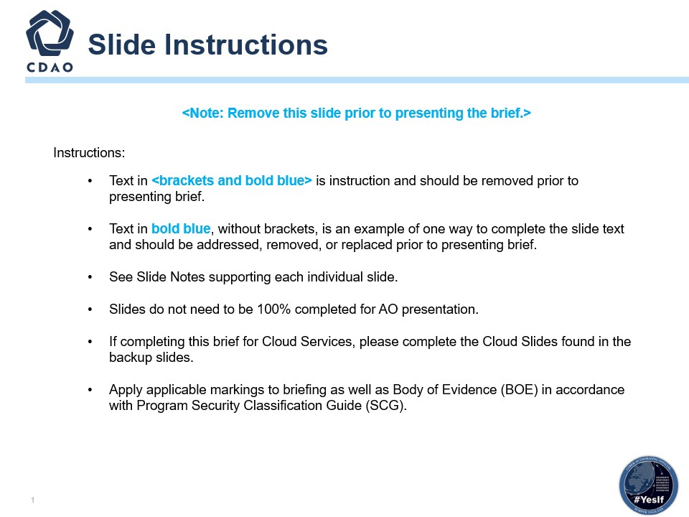

- Deck instructions.
- Complete this slide to incorporate your organization’s Communications Listing.
- It is up to the individual completing this slide deck to determine if their environment is Cloud-related. If it is, there are some Cloud-specific slides that need to be completed. If not, they can remove or hide all the identified Cloud slides.

Title Slide
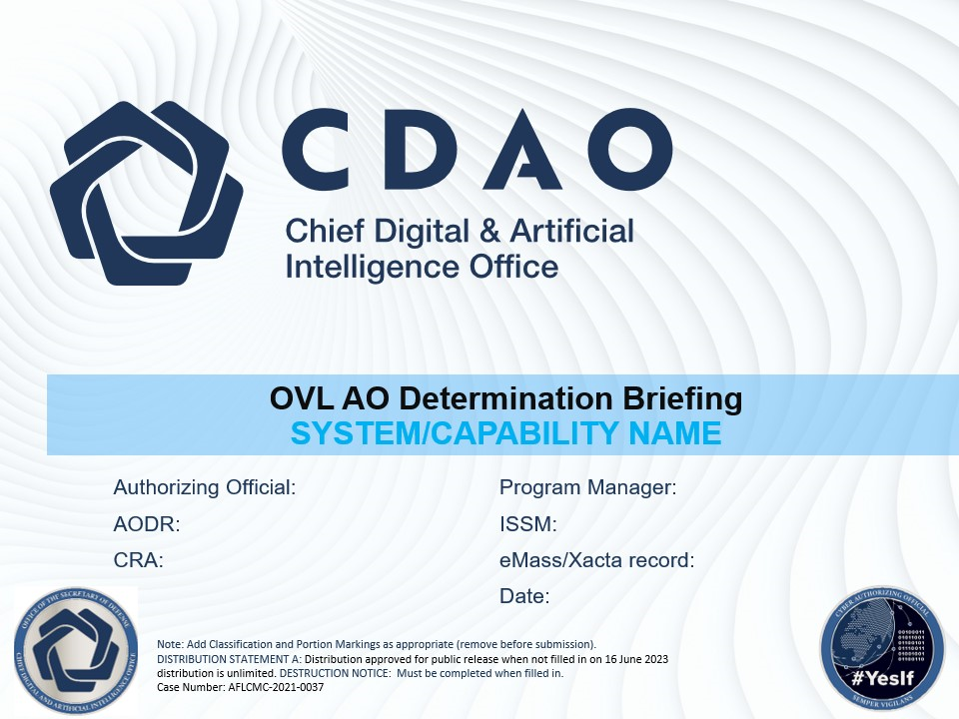

- The title slide identifies who the program owner is, the name of the program, program type (PIT, Enterprise, Software, Rapid Cyber, product, service, component, Cloud, etc.), and the name(s) of the personnel that will be briefing.
- Please add system name, PM, and date​
- This is a joint briefing between the program/system/capability ISSM and the CRA. It is the Executive Summary to the Authorizing Official of the request for a determination. It documents the point in time that the authorization determination is made.​
- It is part of the Authorization Package that is documented.​
- This briefing provides an overview of the system/capability, the architectures, the data flows, the CONOPS, the technologies, the supply chain, the Risk analysis, the mitigated risk areas, the unmitigated risk areas, the POA&M, the CONMON, and the IR.​
- It outlines the system/capability, the risk posture, the agreed-too conditions between the PM and the AO, and the items that will be addressed per the Authorization conditions.​
- This AO Determination Briefing forms the basis for communicating the Risk posture of the System/Capability to other stakeholders and to other AOs, for aiding reciprocity, and for informing others of the risk-of-use posture of the system/capability. ​

Program and AO Team
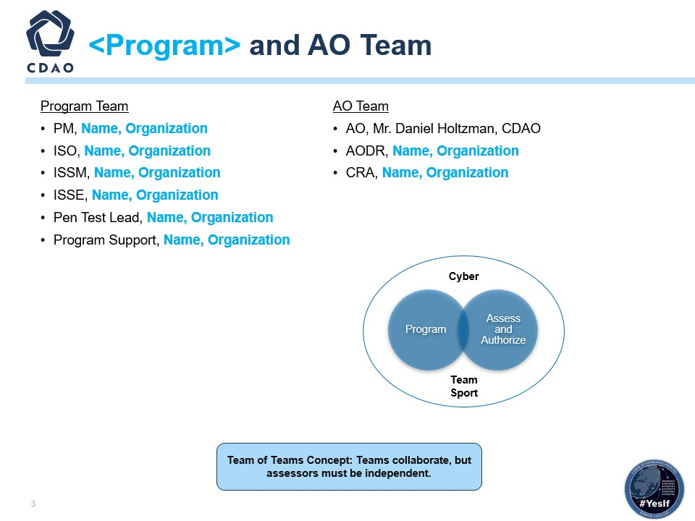

- Complete this slide to identify the individual and team roles.

Bottom Line Up Front (BLUF)
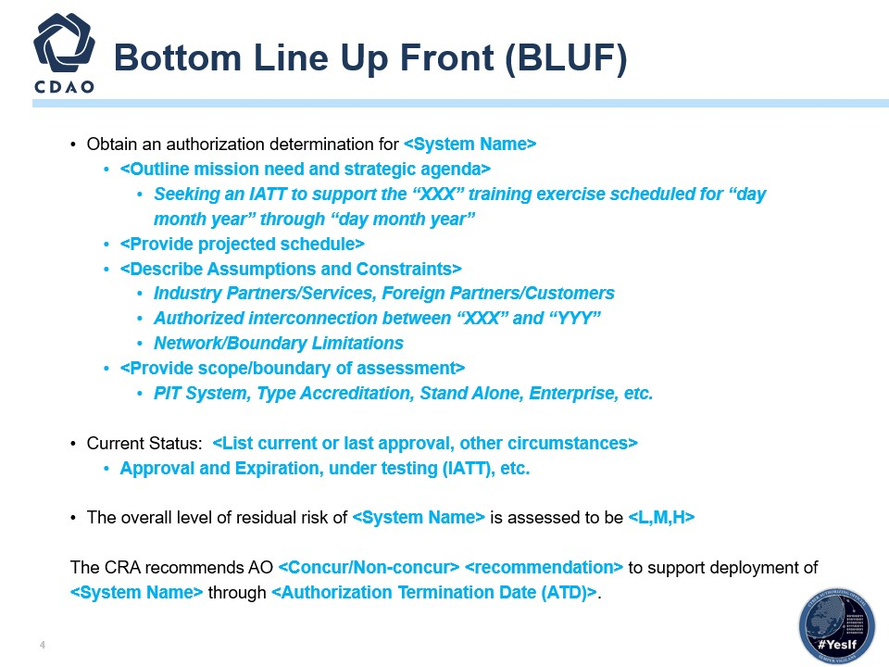

- Bottom Line Up Front: Identify the name of the system, the reason for the requested determination and timeframe the determination is expected, any pertinent information, scope of the assessment, and the current authorization status.
- Reference NIST SP 8510.01 and NIST SP 800-37.
- Describe the intention of the briefing. Why are we here, and what do you want from the AO? Use simple statements, direct and to the point. The determination can be either for ATO, ATO with conditions, IATT, or DATO.
- The line “This is a Type Authorization under Reciprocity” is necessary if it applies, and any other pertinent information needs to be identified up front.
- The current situation should describe previous authorizations and dates or confirm that it is an initial (new) assessment and need date. The AO and CRA need these details up front to understand and assist.
- The Cyber Risk Assessor (CRA) is the official with the authority and responsibility for the assessment of all ISs and PIT systems governed by a DoD Component Cybersecurity Program. The CRA evaluates the cybersecurity capabilities and services of a DoD IS and PIT system and makes a recommendation for risk acceptance or denial to the AO.
- This recommendation accompanies the RMF security authorization package and serves as the primary basis for the AO’s authorization determination. The CRA continuously assesses and guides the quality and completeness of RMF activities and tasks and the resulting artifacts. The DoD Component SISO either performs the CRA functions or formally appoints CRA Representatives to do so for all governed ISs and PIT systems.
- Specific duties include (taken from NIST SP 800-37):
  - Develop, review, and approve a plan to assess the risk.
  - Assess the security risks in accordance with the assessment procedures defined in the security assessment plan.
  - Prepare the security assessment report, documenting the issues, findings, and recommendations from the security risk assessment.
  - Conduct initial remediation actions on security risks based on the findings and recommendations of the security assessment report and reassess remediated risk(s) as appropriate.
  - Assess a selected subset of the technical, managemental, and operational security risks employed within and inherited by the information system in accordance with the Organization-Defined Monitoring Strategy.

Mission and System Description
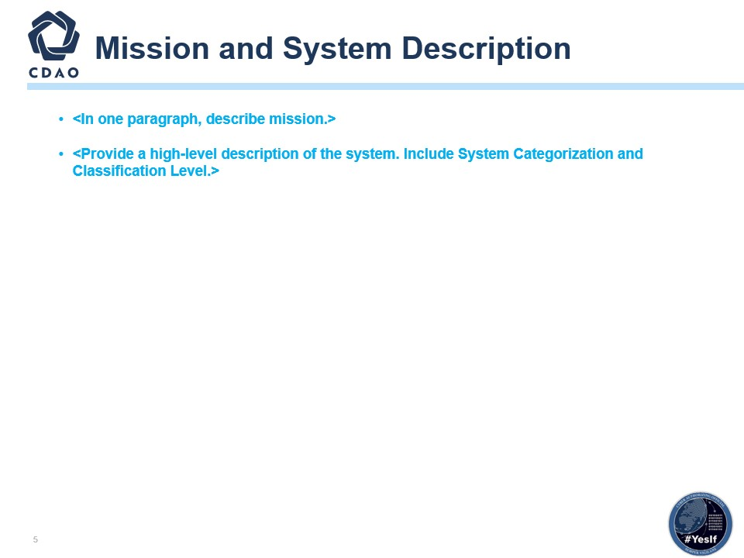

- EXECUTIVE-LEVEL CHART ONLY; focusing on program capabilities.
- Mission Description: In one paragraph, describe the mission. Provide a concise overview of the mission’s purpose, objectives, and key outcomes. Highlight the significance and impact of the mission in clear and compelling language.
- Need to describe from a high-level overview (1 paragraph or less) your mission objective (MVP) supporting this need and what the system will intel.
- System Overview: Provide a high-level description of the system, including system categorization and classification level. Briefly outline the system’s function, its role within the organization, and its categorization (Confidentiality, Integrity, Availability) (e.g., CCS) and classification level (e.g., CUI, Secret, Top Secret). Ensure clarity and relevance for the intended audience.
- What details did you provide in the CCS?
- You will need to describe from a high-level overview in a generalized viewpoint both the mission and information system requirements driving the need for a new information system authorization.

Cybersecurity and Resilience Enablers
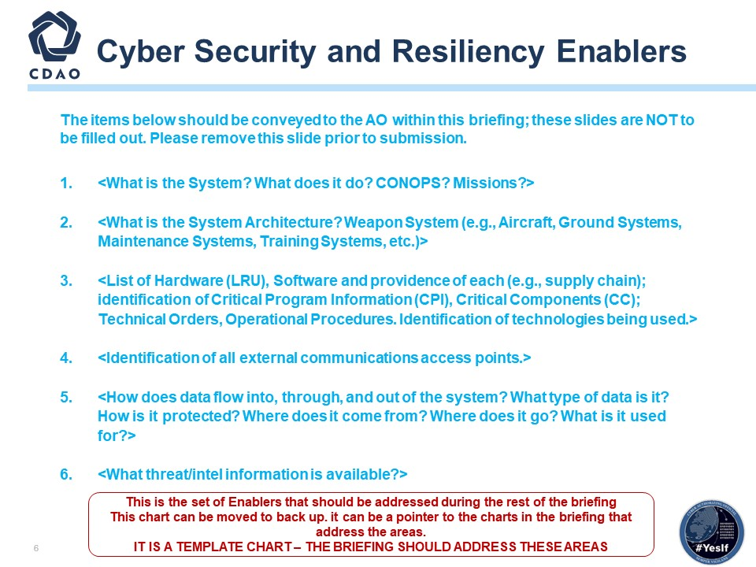

- Reference NIST Special Publication 800-161.
- System Overview: Describe what the system is designed to do, how it operates within its operational concept (CONOPS), and the specific mission it supports.
- System Architecture: Outline the structural design and components of the system, emphasizing its role and categorization within the broader context of the capability.
- Hardware, Software, and Critical Information: Provide a detailed inventory of hardware and software components, their sources, criticality, and any pertinent technical and operational documentation. Mention the technologies integrated into the system.
- External Communications Access Points: List and describe the external interfaces and communication channels used by the system to interact with external entities or networks.
- Data Flow and Protection: Detail the data handling processes within the system, including data types, security measures, origins, destinations, and utilization purposes.
- Threat/Intel Information: Summarize the current threat landscape and available intelligence pertinent to the system’s operations and security posture.

Supply Chain Risks
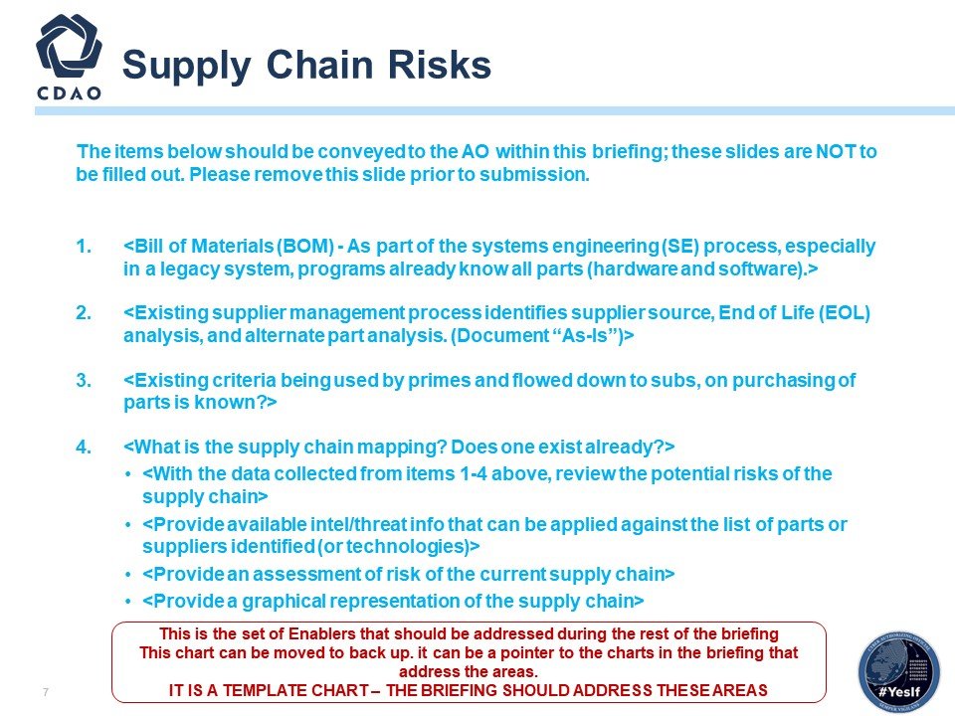

- Identify your program’s supply chain risks for the information system.
- Bill of Materials (BOM): Include a detailed BOM outlining all components of the system, categorized by hardware and software, as per the existing knowledge base.
- Supplier Management Process: Describe how suppliers are currently managed, including processes for identifying sources, conducting EOL and alternate part analyses, and any documentation reflecting the current state (“As-Is”).
- Criteria for Purchasing Parts: Outline the established criteria and guidelines used in the procurement process for parts, detailing requirements imposed by prime contractors and how these are communicated to subcontractors.
- Supply Chain Mapping: Assess the presence and detail of an existing supply chain map, if available, outlining the relationships and dependencies among suppliers, manufacturers, and distributors involved in the supply chain.
- Supply Chain Risks: Analyze and present potential risks such as supplier dependencies, part availability issues, and vulnerabilities identified through the BOM, supplier management processes, purchasing criteria, and supply chain mapping.
- Intel/Threat Information: Summarize any pertinent intelligence or threat data that could impact the identified parts, suppliers, or technologies within the supply chain.
- Assessment of Supply Chain Risk: Present an assessment of the identified risks, providing insights into the overall risk posture of the current supply chain environment.
- Graphical Representation of Supply Chain: Create a visual diagram illustrating the relationships and flow within the supply chain, highlighting key suppliers, manufacturers, distributors, and dependencies.

System Architecture
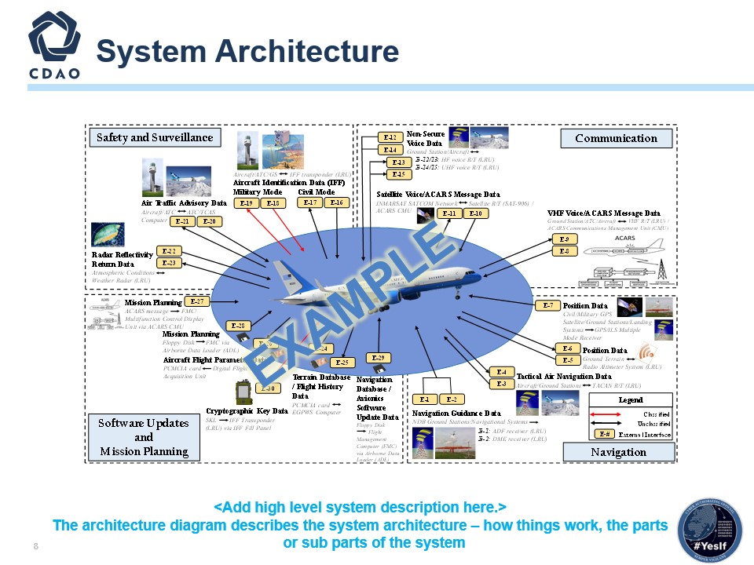

- Reference only; replace architecture.
- The system architecture should show the AO what the architecture is, its physical location, encryption, interfaces and protocols, physical and technical protection mechanisms, vendor access, etc.
- A system architecture is the conceptual model that defines the structure and behavior and supplies more views of a system. An architecture description is a formal description and representation of a system, organized in a way that supports reasoning about the structures and behaviors of the system. Identify the architecture, locations, encryption, interfaces, protocols, physical and technical protection measures, vendor access, etc.

Interconnections and Interfaces
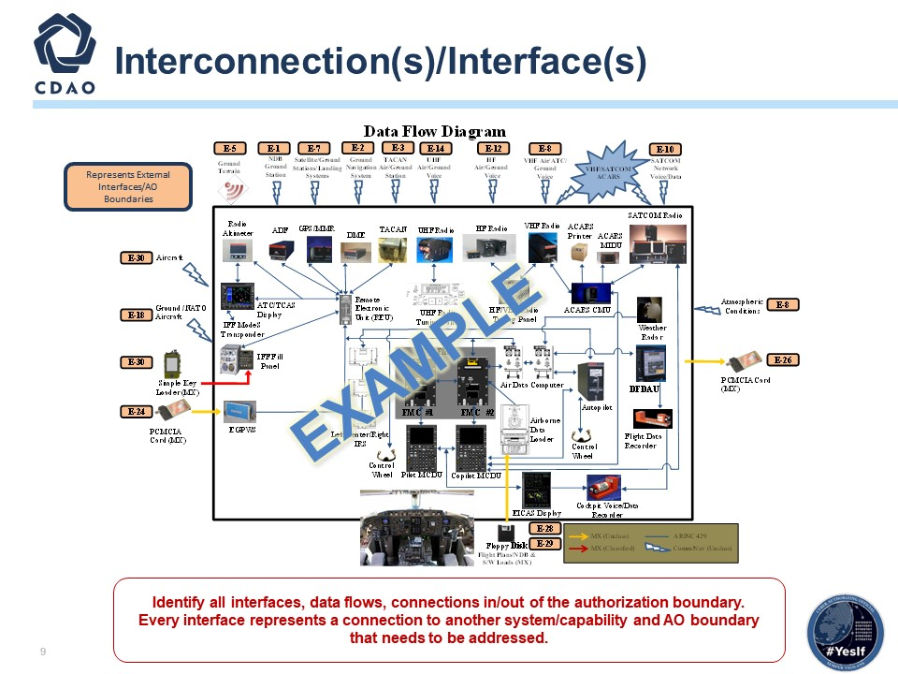

- Reference only; replace architecture.
- Describe the interconnections/data flows this system has with any external systems or networks. Describe what the external connections are: PITIs, other external connections, standalone system, etc.

3.10 Authorization Boundary
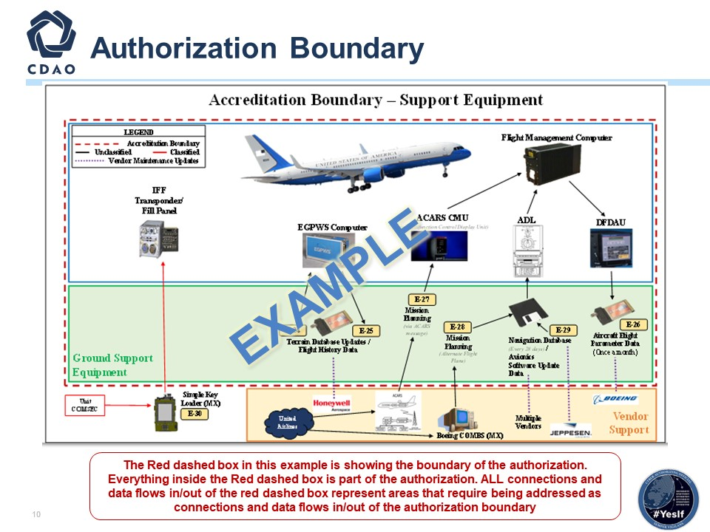

- Reference only; replace architecture.
- The authorization boundary diagram must specifically identify what is included in the boundary. The AO risk acceptance determination will be strictly based on threat/vulnerability pairs identified within the specific boundary.
- The main purpose of this chart is an example of WHAT is in the boundary of the Authorization that the AO is being asked to assess and make a determination on, as shown by the RED dashed line (see the legend). What is IN the boundary of the authorization, and what is EXTERNAL to the boundary of the authorization?
- This chart is an example of an “Airplane Weapon System” boundary.

Authorization Boundary Continued
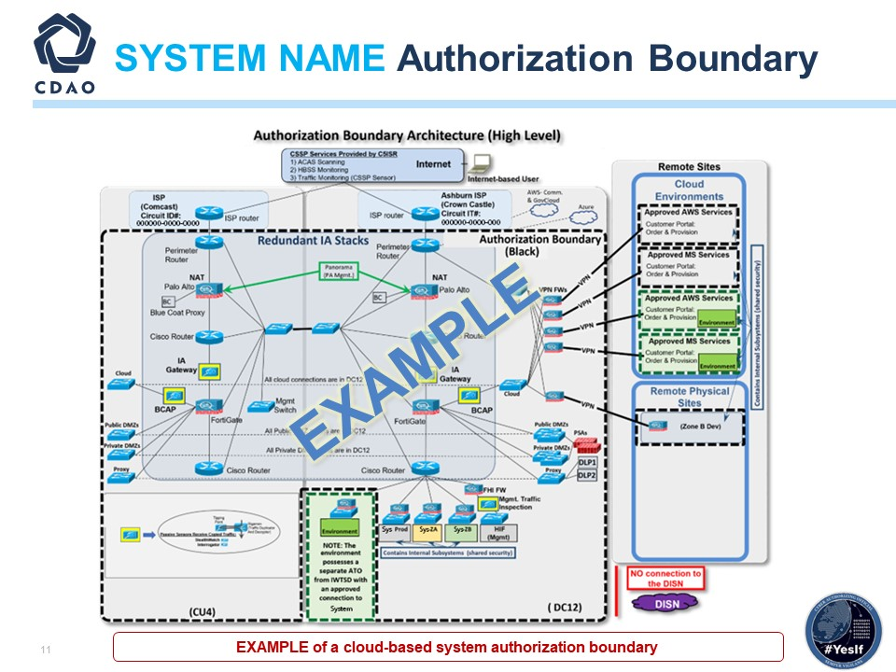

- Reference only; replace with your capability’s authorization boundary diagram.
- This shows what is authorized. It should have a legend and be standard across all Tag Up Briefings. For example, this chart shows TWO authorizations, one in black dashes and one in green dashes. This should show the AO what is under their authorization. It should have a very clear line or box around the area that is within the ATO.
- Illustrates what the AO is responsible for with a key on the chart so that it is easily understood. This chart should be the same in the AO determination briefing (or should be at that point in time, and then we monitor change from that point forward).

Mission Partners
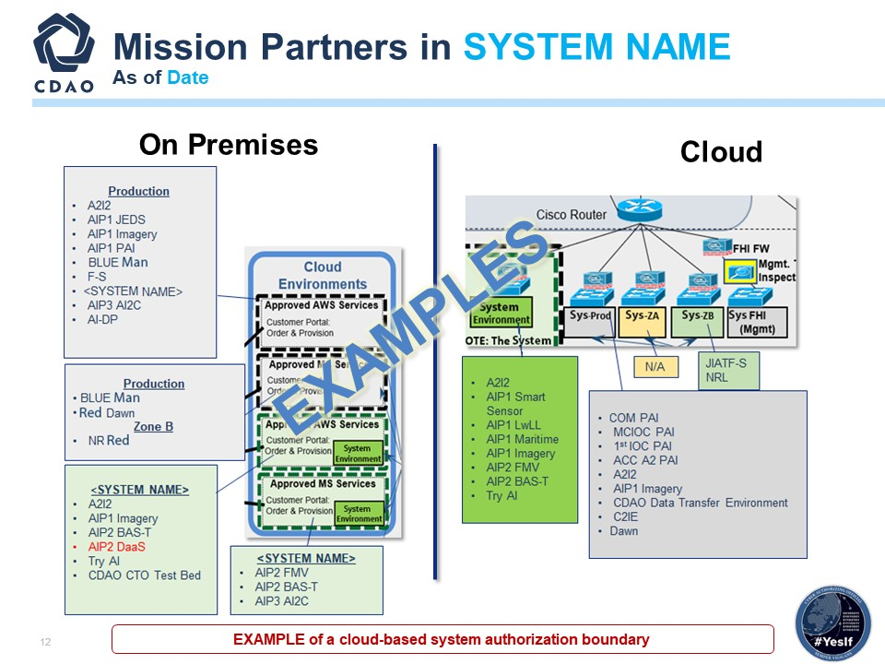

- Reference only; replace with your capabilities mission partner chart.
- In this case, this program shows a second chart to outline the workloads within the system.
  - Note that this is a second authorization boundary chart with more detail.
  - It is the Operational View of how the capability is being used and the 18 different workloads inside the capability.
  - It shows the various cloud zones of the capability (e.g., prod, ZA, ZB, etc.). This gives the AO and team an understanding of “how” the capability is being authorized and is being used.

Cyber Tech Order and Continuous Monitoring
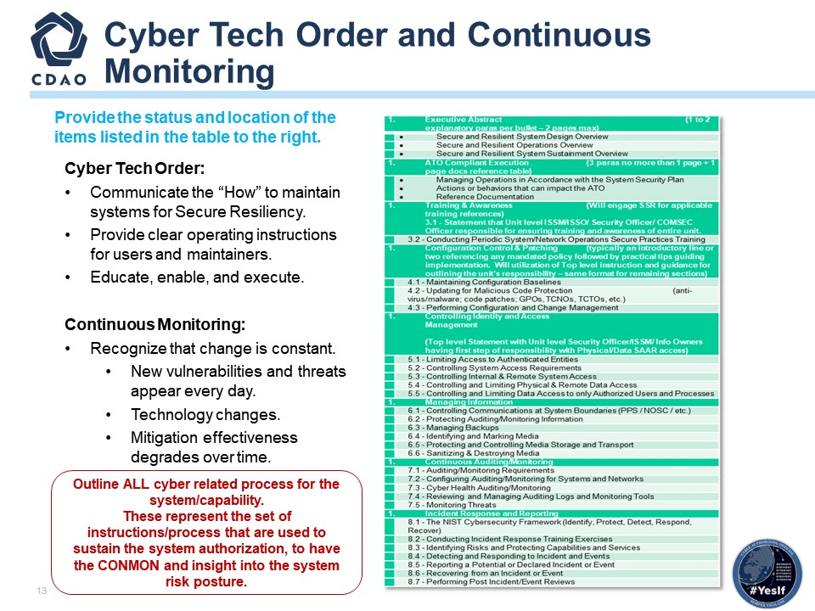

- Cyber Tech Order Overview: Provide a high-level overview of each component of the Cyber Tech Order, detailing how the organization has implemented and is maintaining alignment with these requirements.
- System Security Plan (SSP): Explain the security measures, controls, policies, and procedures outlined in the SSP to protect the system and its information assets from cybersecurity threats.
- Concept of Operations (CONOPS): Provide an overview of how the system is intended to operate, including roles and responsibilities related to cybersecurity, processes for handling incidents, and interactions with other systems or stakeholders.
- Cybersecurity Strategy: Discuss the overarching approach to cybersecurity, including goals, objectives, risk management strategies, and how these align with organizational objectives and industry best practices.
- Incident Response Plan (IRP): Describe the procedures, roles, and responsibilities for detecting, responding to, mitigating, and recovering from cybersecurity incidents affecting the system.
- Continuous Monitoring: Explain how continuous monitoring activities are conducted to detect and respond to cybersecurity threats in real-time, including monitoring tools, metrics, frequency, and reporting mechanisms.

CDAO ORTB
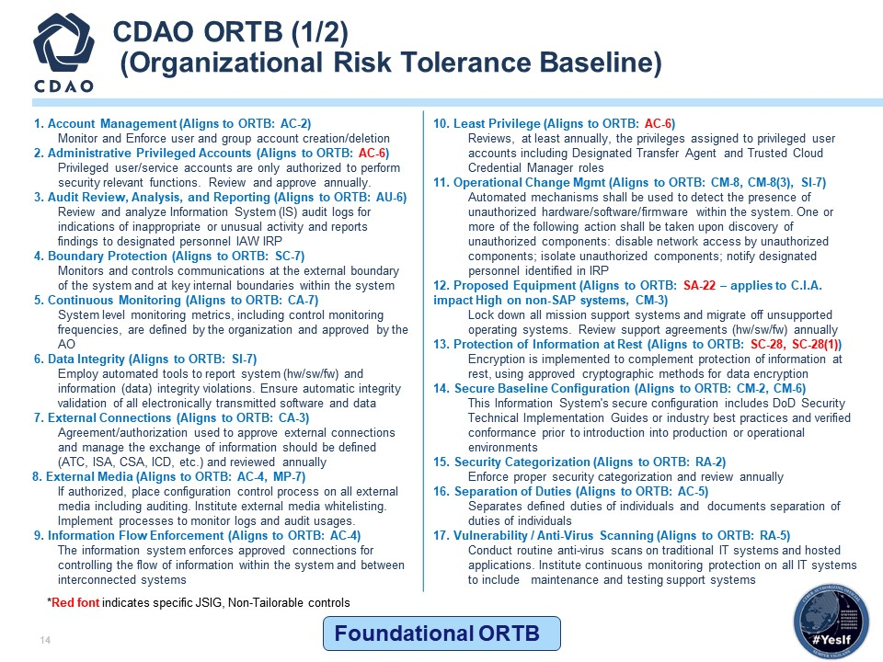

- ORTB Overview: Provide an overview of the approach taken to assess and address each identified security control, including whether they have been Implemented, Partially Implemented, Not Implemented, or are Not Applicable.
- It is recommended that you break each control into their own slide to break down whether that control has been satisfied and how.
- Be sure to generate a legend showing the colors used to determine implementation status (e.g., green for Implemented, yellow for Partially Implemented, red for Not Implemented, purple for Not Applicable).

CDAO ORTB – AI View
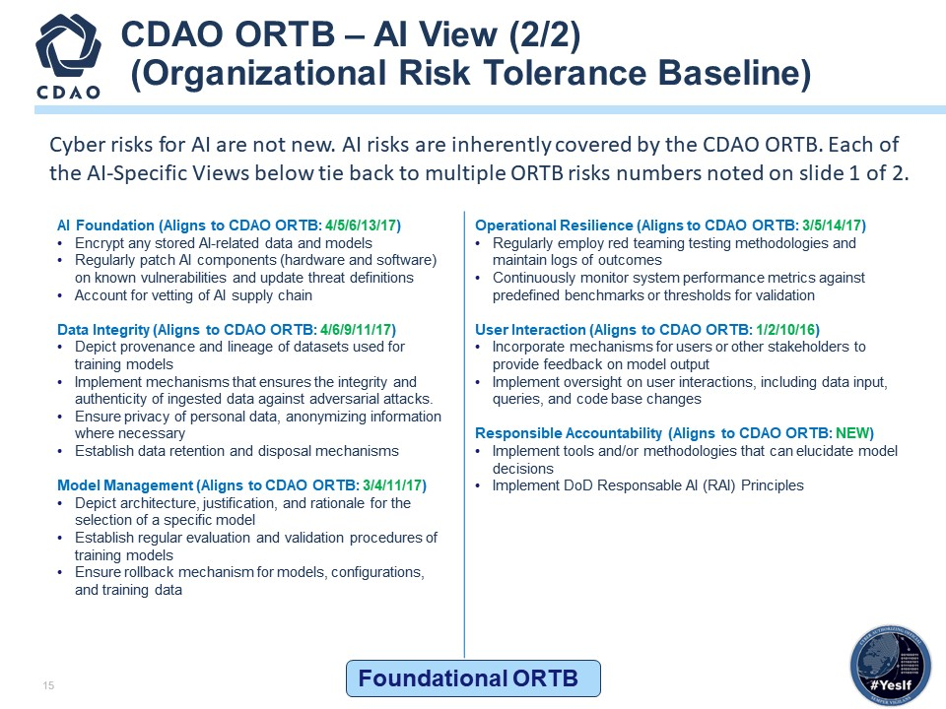

- ORTB AI Overview: Explain whether each focus point has been Implemented, Partially Implemented, Not Implemented, or is Not Applicable to your organization’s AI initiatives.
- AI Foundation: Describe the foundational principles and policies in place to govern AI development, including ethical considerations and alignment with organizational goals.
- Encryption: Discuss encryption methods used to protect AI data and models, including encryption standards and practices for data at rest and in transit.
- Regularly Patch AI Components: Detail how AI components are regularly updated with security patches and updates to mitigate vulnerabilities and ensure system integrity.
- Account Vetting: Explain how user accounts are verified and authenticated to ensure only authorized access to AI systems and data.
- Data Integrity: Outline measures and controls implemented to verify and protect the accuracy and reliability of data used in AI models and applications.
- Model Management: Detail the process for model development, testing, deployment, monitoring, and retirement, including version control and model performance evaluation.
- Operational Resilience: Discuss strategies and contingency plans to maintain AI system functionality during disruptions or incidents, ensuring continuity of operations.
- User Interaction: Explain user interface design, usability considerations, and user feedback mechanisms to enhance user experience and optimize AI system interaction.
- Responsible Accountability: Outline governance frameworks, accountability measures, and transparency practices to address ethical, legal, and societal implications of AI deployment.
- It is recommended that you break each control into their own slide to break down whether that control has been satisfied and how.
- Be sure to generate a legend showing the colors used to determine implementation status (e.g., green for Implemented, yellow for Partially Implemented, red for Not Implemented, purple for Not Applicable).

Risk Assessment Model
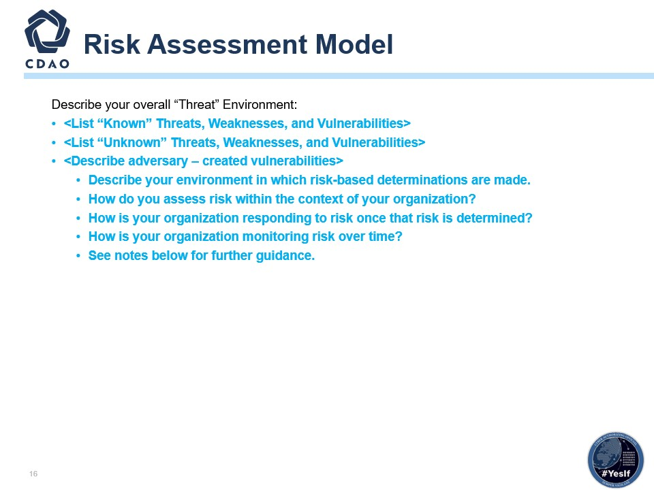

- Refer to NIST SP 800-30 DoD Risk Assessment Guide Task 2.3.1.
- Risk models define the risk factors to be assessed and the relationships among those factors. Risk factors are characteristics used in risk models as inputs to determine levels of risk in risk assessments. Risk factors are also used extensively in risk communications to highlight what strongly affects the levels of risk in particular situations, circumstances, or contexts. Typical risk factors include threat, vulnerability, impact, likelihood, and predisposing condition. Risk factors can be decomposed into more detailed characteristics (e.g., threats decomposed into threat sources and threat events). ​
  - The purpose of the risk framing component is to produce a risk management strategy that addresses how your organization intends to assess risk, respond to risk, and monitor risk, making explicit and transparent the risk perceptions that your organizations routinely use in making both investment and operational decisions. The risk management strategy establishes a foundation for managing risk and delineates the boundaries for risk-based decisions within organizations.​
  - The purpose of the risk assessment component is to identify: (i) threats to organizations (i.e., operations, assets, or individuals) or threats directed through organizations against other organizations or the Nation; (ii) vulnerabilities internal and external to organizations; (iii) the harm (i.e., adverse impact) that may occur given the potential for threats exploiting vulnerabilities; and (iv) the likelihood that harm will occur. The result is a determination of risk (i.e., typically a function of the degree of harm and likelihood of harm occurring).​
  - The purpose of your organization’s risk response component is to provide a consistent, organization-wide response to risk in accordance with the organizational risk frame by: (i) developing alternative courses of action for responding to risk; (ii) evaluating the alternative courses of action; (iii) determining appropriate courses of action consistent with organizational risk tolerance; and (iv) implementing risk responses based on selected courses of action.​
  - The purpose of your risk monitoring component is to: (i) determine the ongoing effectiveness of risk responses (consistent with the organizational risk frame); (ii) identify risk-impacting changes to organizational information systems and the environments in which the systems operate; and (iii) verify that planned risk responses are implemented and information security requirements derived from and traceable to organizational missions/business functions, federal legislation, directives, regulations, policies, standards, and guidelines are satisfied. ​

Assessment Approach
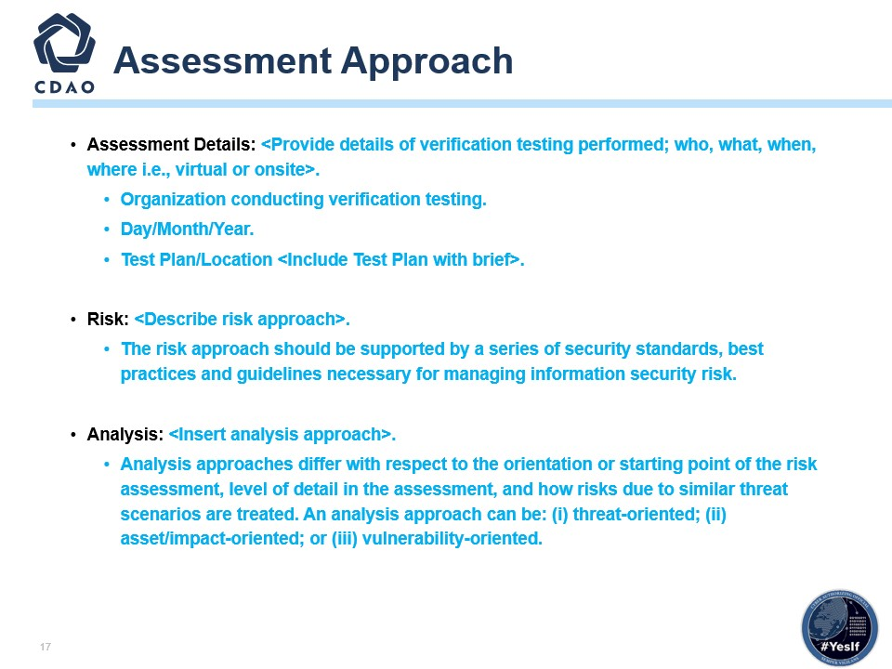
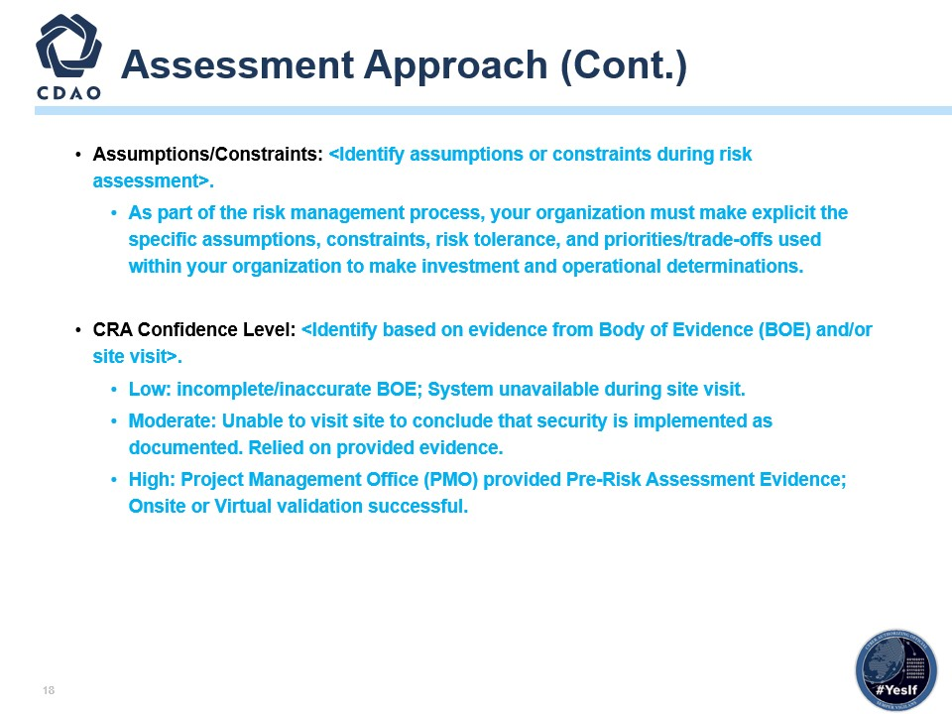

- Reference NIST SP 800-30 Rev1; NIST SP 800-53 Rev4; NIST SP 800-39; CNSSI 4009-2015.
- First and foremost, THINK OUTSIDE OF THE BOX! Do not rely on a checklist approach when conducting your analysis and assessments.
- Leveraging the tools and resources available to you via the RMF will ensure you are mitigating the necessary risks from a DoD standard, but you MUST always examine each assessment individually and ensure it is properly tailored to meet the amount of security that makes the most strategic and mission sense moving forward.

- How?
- Analysis approaches differ with respect to the orientation or starting point of the risk assessment, level of detail in the assessment, and how risks due to similar threat scenarios are treated. An analysis approach can be (i) threat-oriented, (ii) asset/impact-oriented, or (iii) vulnerability-oriented.

- Why?
- A threat-oriented approach starts with the identification of threat sources and threat events and focuses on the development of threat scenarios; vulnerabilities are identified in the context of threats, and for adversarial threats, impacts are identified based on adversary intent.
- An asset/impact-oriented approach starts with the identification of impacts or consequences of concern and critical assets, possibly using the results of a mission or business impact analyses and identifying threat events that could lead to and/or threat sources that could seek impacts or consequences.
- A vulnerability-oriented approach starts with a set of predisposing conditions or exploitable weaknesses/deficiencies in organizational information systems or the environments in which the systems operate and identifies threat events that could exercise those vulnerabilities together with possible consequences of vulnerabilities being exercised. Each analysis approach takes into consideration the same risk factors and thus entails the same set of risk assessment activities, albeit in a different order.
- Differences in the starting point of the risk assessment can potentially bias the results, causing some risks not to be identified. Therefore, identification of risks from a second orientation (e.g., complementing a threat-oriented analysis approach with an asset/impact-oriented analysis approach) can improve the rigor and effectiveness of the analysis.

- CRA Recommendation:
- Based on the Body of Evidence provided, the CRA must be able to summarize risk assessment results in a form enabling decision makers to quickly understand the overall risk while considering the number of threat events for different combinations of likelihood and impact and the relative proportion of threat events at different risk levels.

Cyber Test Schedule
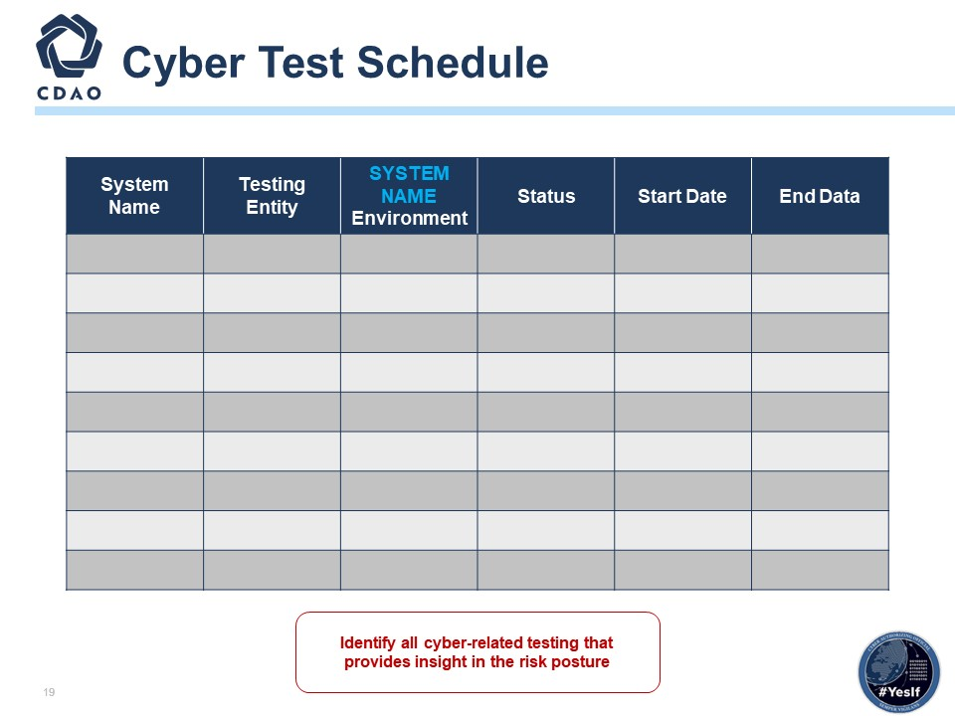

- Detail any Capability testing that is projected to occur (e.g., Tabletop exercises, Penetration Testing, etc.).

PenTest Schedule
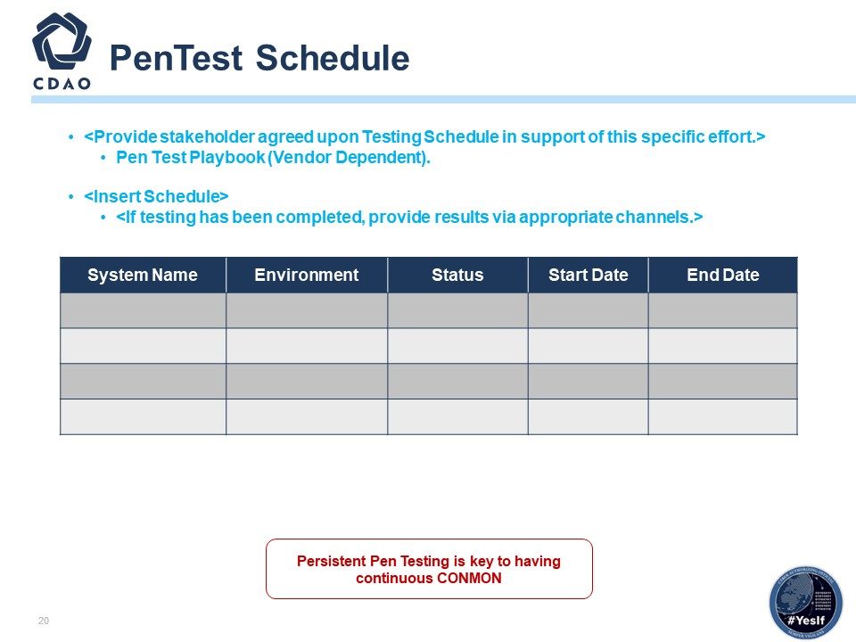

- This chart and the next chart will show what Pen Tests or other tests are planned and when. There is a holistic site picture.​
- This could also be augmented by a traditional schedule view​.
- Provide stakeholder agreed upon Testing Schedule in support of this specific effort​.
- If testing has been completed, provide results via appropriate channels.
- Please see NIST SP 800-115, Technical Guide to Information Security Testing and Assessment​.
- A Penetration Test, also known as a “Pen Test” or “Ethical Hacking,” is an authorized, simulated cyberattack on an Information System performed to evaluate the security state of the system. ​
- Pen Testing is an augmentation to the overall risk assessment and continuous monitoring.
- Coordinate and schedule with your contracted Pen Testing team to ensure that you are getting your Information System Pen Testing accomplished and that the findings of the Pen Test are published to the organization and are submitted as part of the Authorizing Official’s required Body of Evidence.​
- Penetration Testing usually relies on performing both network port/service identification and vulnerability scanning to identify hosts and services that may be targets for future penetration. Also, multiple technical ways exist to meet an assessment requirement, such as determining whether patches have been applied properly.​

Risk Scale Summary
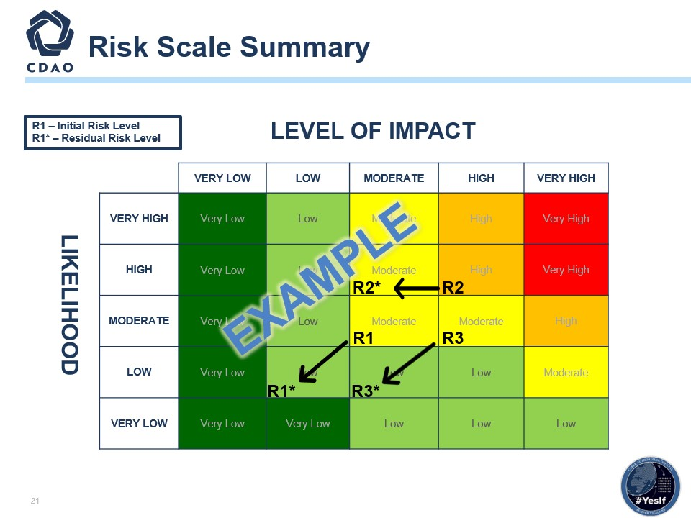

- Reference only; replace with your program’s Risk Scale Summary diagram.
- Show initial risk and residual risk after mitigation.
- This table is from the DoD Risk Assessment Guide based on NIST SP 800-30, but reference NIST SP 800-39, Managing Information Security Risk to determine Level of Impact.

Risk Analysis Report
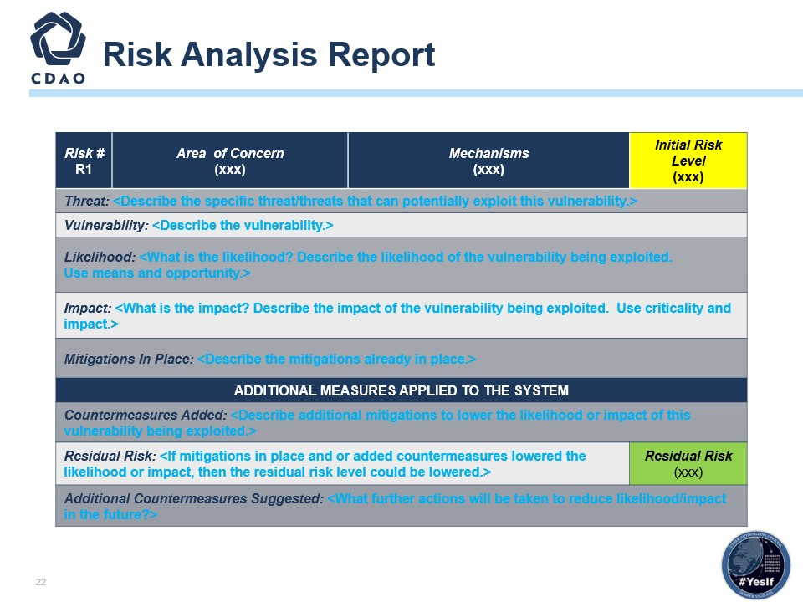

- Reference only; replace with your program’s Risk Analysis Report.
- Reference NIST SP 800-30 Rev.1.
- This is the process of identifying, estimating, and prioritizing risks to organizational operations (including mission, functions, image, reputation), organizational assets, individuals, other organizations, and the Nation, resulting from the operation of an information system. Part of risk management incorporates threat and vulnerability analyses and considers mitigations provided by security risks planned or in place. Synonymous with risk analysis.

Mitigating Factors
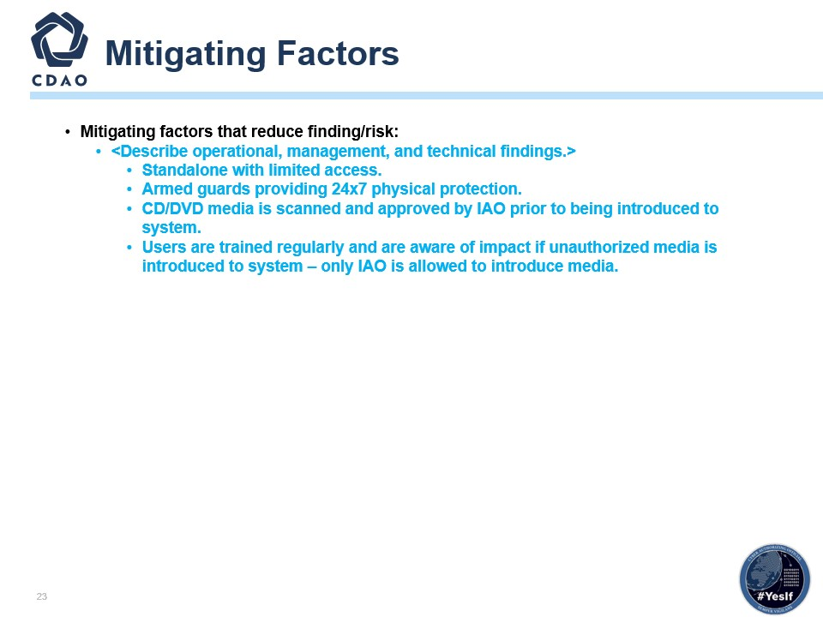

- You have identified the risks; now explain how to mitigate each of the findings.
- Reference NIST SP 800-39, Managing Information Security Risk (i.e., Scan Results, Penetration Test Findings, PPSM).

Summary
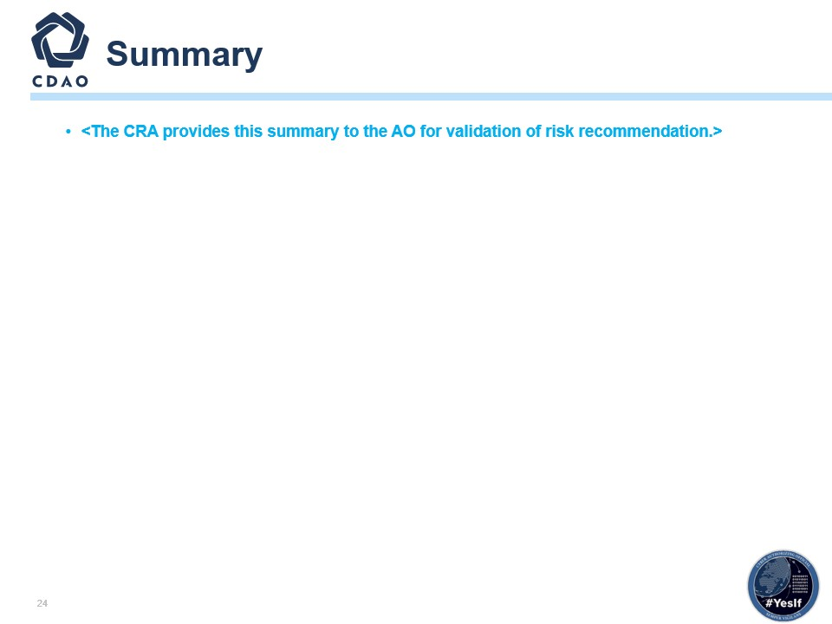

- This is the summary template chart. ​
- The intent is for a program to add its own summary here.​
- NOTE: this is not the AO summary; the CRA is to add their own summary.

Backup Slides
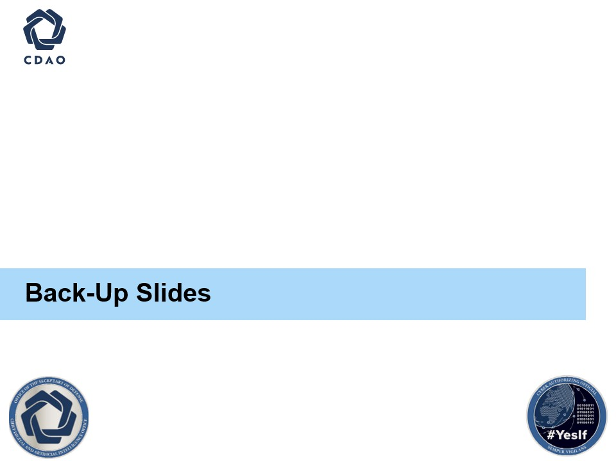

- Provide any additional information in the backup slides as needed.

Impact Level Comparison
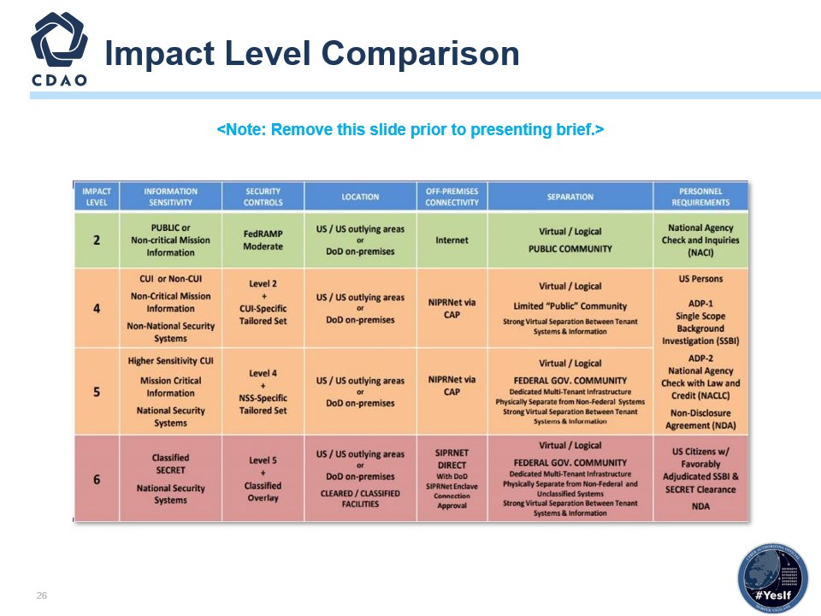

- Reference only; remove slide before submission.
- Reference “DoD Cloud Computing SRG v1 Rev 3, Section 3.2 Information Impact Levels” for further guidance.

Cloud System Architecture
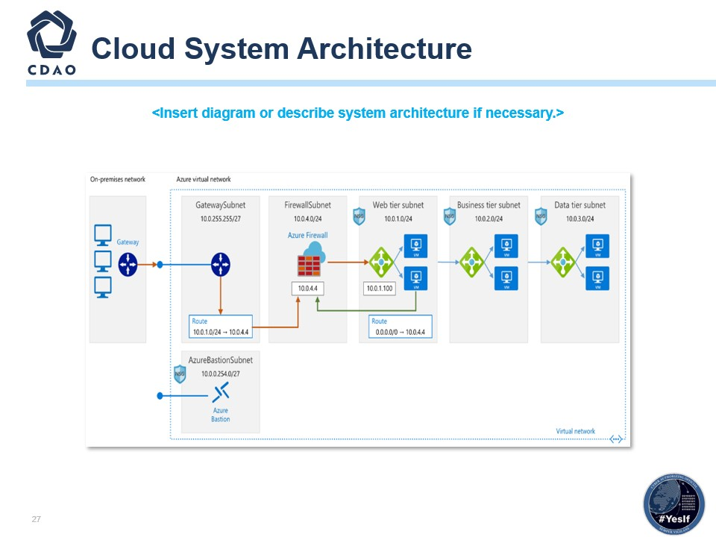

- Reference only; replace architecture.
- Reference DoD Secure Cloud Computing Architecture Functional Requirements (SCCA).
- https://dl.dod.cyber.mil/wp-content/uploads/cloud/pdf/SCCA_FRD_v2-9.pdf.
- The system architecture should show the AO what the architecture is, its physical location, encryption, interfaces and protocols, physical and technical protection mechanisms, vendor access, etc.
- Ensure you are showing your supporting infrastructure service(s) (IaaS, SaaS, PaaS), and show your Development Security Operations Platform (DSOP).
- A system architecture is the conceptual model defining the structure and behavior and supplying more views of a system. An architecture description is a formal description and representation of a system organized in a way that supports reasoning about the structures and behaviors of the system. Identify the architecture, locations, encryption, interfaces, protocols, physical and technical protection measures, vendor access, etc.

Cloud Data Flow Diagram
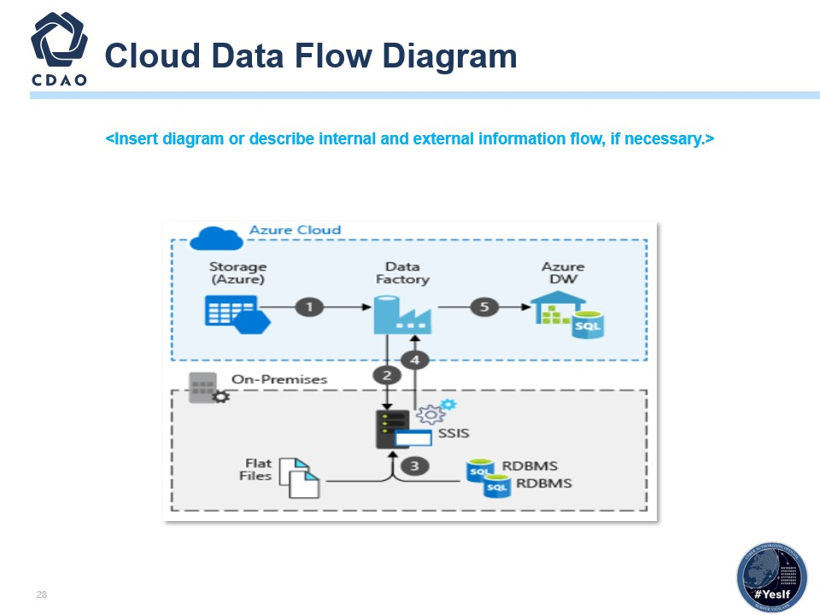

- Replace with your program’s information systems data flow diagram.
- Reference NISTIR 8179 Criticality Analysis Process Model.
- https://csrc.nist.gov/CSRC/media/Publications/nistir/8179/draft/documents/nistir-8179-draft.pdf.
- The data flow diagram must specifically identify what the data flow connections look like within and while leaving the defined boundaries. The AO risk acceptance determination will be strictly based on threat/vulnerability pairs identified within the specific boundary.
- In computing, the path of data flows from source document to data entry, processing, and then final reports. Data changes format and sequence (within a file) as it moves from program to program. A data flow diagram is a way of representing a flow of data through a process or a system (usually an information system). The data flow diagram also provides information about the outputs and inputs of each entity and the process itself. A data flow diagram has no risk flow; there are no decision rules and no loops. Data flow diagrams are used to graphically represent the flow of data in a business information system. Data flow diagrams describe the processes involved in a system to transfer data from the input to the file storage and reports generation. Data flow diagrams can be divided into logical and physical. Data flow diagrams are built using standardized symbols and notation to describe various entities and their relationships.

Cloud Authorization Boundary
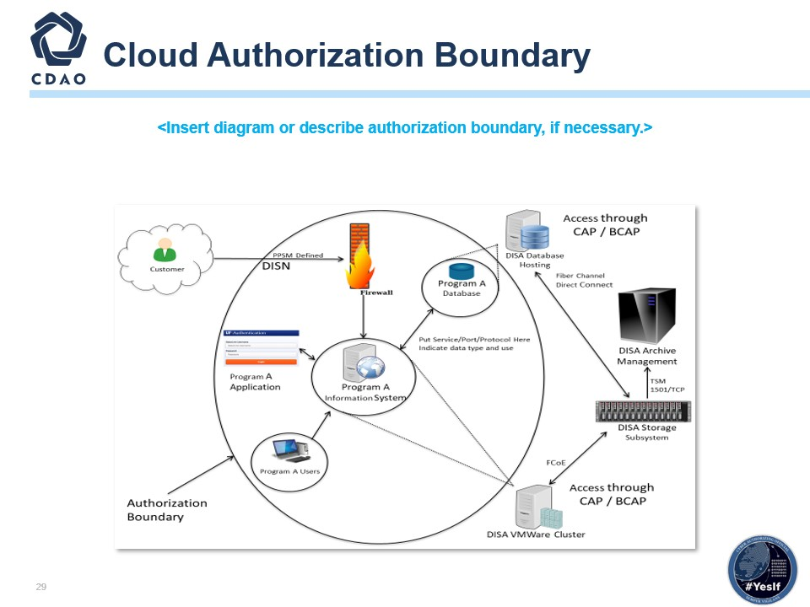

- Replace with your program’s information system boundary diagram.
- Identify all areas to be included within the authorization determination. Any major component/device used within or by the system must be included in the boundary diagram unless the component/device has its own authorization (proof required).
- Interconnection(s)/Interface(s).
- Reference NIST SP 800-47 Security Guide for Interconnecting Information Technology Systems.
- Include any/all Interconnection(s)/Interface(s) that would be leveraged – See below for further details.
- The intent of the ISA is to document and formalize the interconnection arrangements between “Organization A” and “Organization B” and to specify any details that may be required to provide overall security safeguards for the systems being interconnected. ISAs are always negotiable.
- General guidance regarding the contents of an ISA is provided below; however, an ISA may be tailored by mutual consent of the participating organizations.
- A system that has an interconnection with another organization’s system should meet the protection requirements equal to or greater than those implemented by the other
organization’s system.

Cybersecurity Service Provider (CSSP) or Equivalent Services
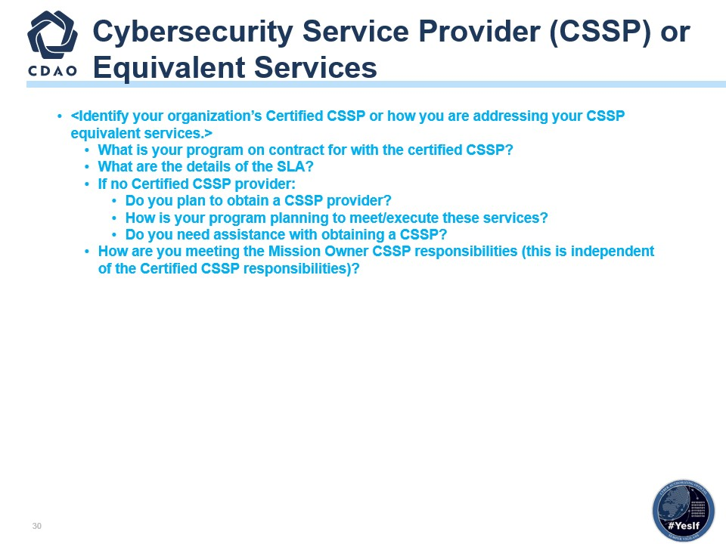

- If you are providing your own services, please explain what services are being conducted and include what DISA support has been approved or needed.
- Per DoD Mandate 17-0019, DoDI 8530.01, you need a Cybersecurity Service Provider (CSSP), or your organization needs to be able to support similar services that meet the DoD requirements. CSSPs are required for both on-premises and Cloud information systems. Establish Cyber Defense (CD) services through one of the 23 DoD-certified CSSPs for Mission Cyber Defense (MCD).

Equivalent CSSP Services
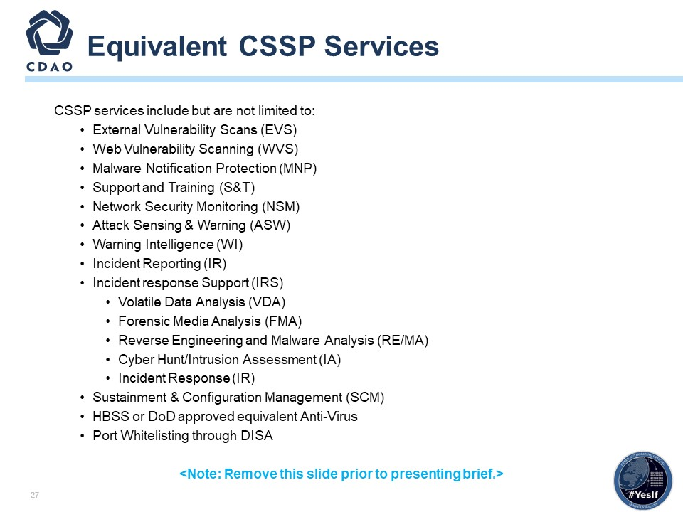

OVL Authorization Package
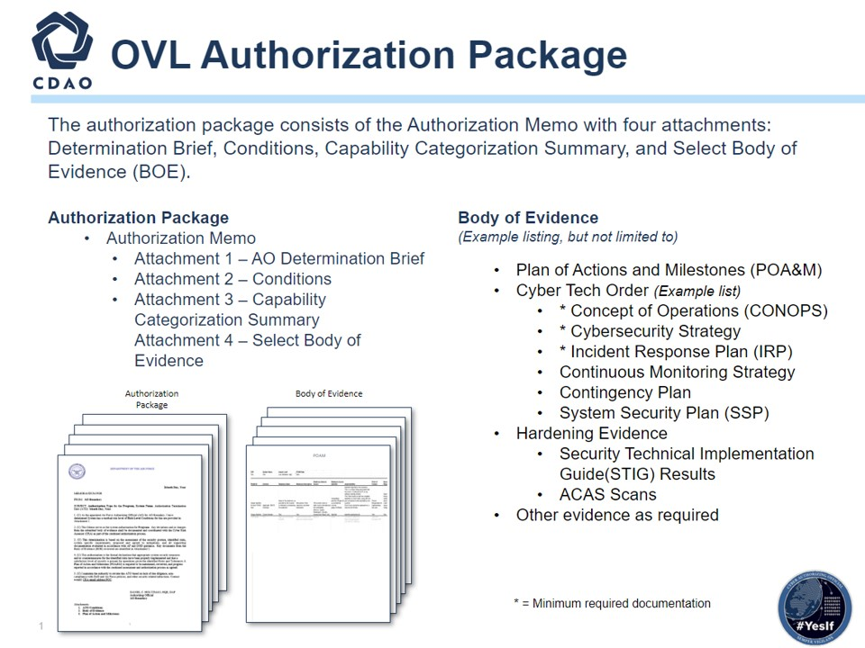

SAP Protection Levels
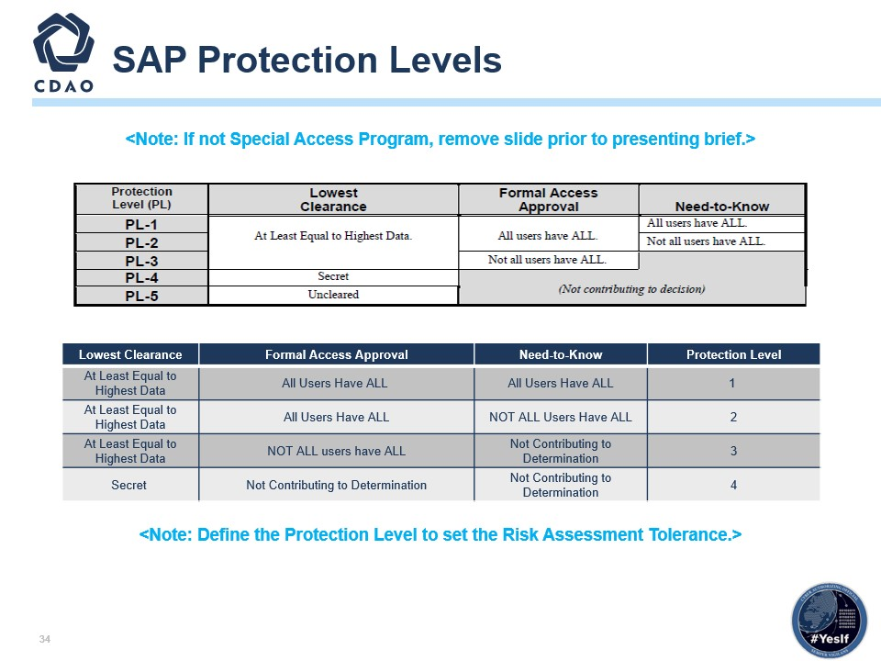

- The concept of Protection Levels applies only to confidentiality. Having verified that an IS will maintain, process, or transmit intelligence information and therefore that its Level of​ Concern for confidentiality must be High, the AO will ascertain the appropriate Protection Level for the IS based on the required clearance(s), formal access approval(s), and​ need-to-know of all direct and indirect users who receive information from the IS without manual intervention and reliable human review. It indicates an implicit level of trust that is​ placed in the system’s technical capabilities.​
- Determining Protection Levels:
  - An IS operates at Protection Level 1 when all users have all required approvals for access to all information on the IS. This means that all users have all required clearances, formal access approvals,​ and the need-to-know for all information on the IS.
  - An IS operates at Protection Level 2 when all users have all required formal approvals for access to all information on the IS, but at least one user lacks administrative approval for some of the​ information on the IS. This means that all users have all required clearances and all required formal access approvals, but at least one user lacks the need-to-know for some of the information on the​ IS. ​
  - An IS operates at Protection Level 3 when at least one user lacks at least one required formal approval for access to all information on the IS. This means that all users have all required clearances, but at least one user lacks formal access approval for some of the information on the IS. ​
  - An IS operates at Protection Level 4 when at least one user lacks sufficient clearance for access to some of the information on the IS, but all users have at least a Secret clearance. ​
  - An IS operates at Protection Level 5 when at least one user lacks any clearance for access to some of the information on the IS.​

SAP Body of Evidence
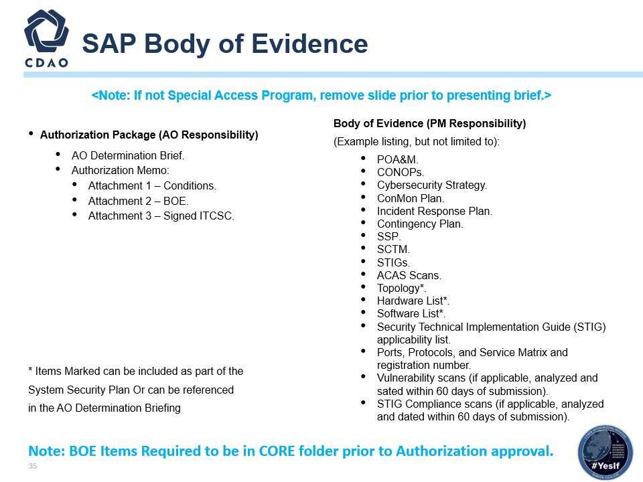

SAP Connection Package Required Documentation
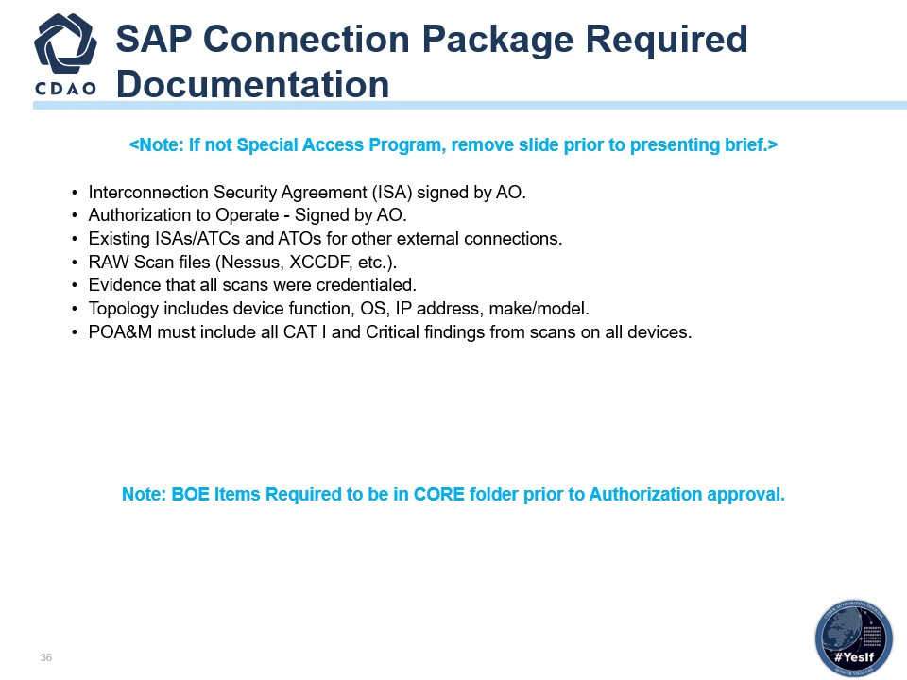

SAP ORTB
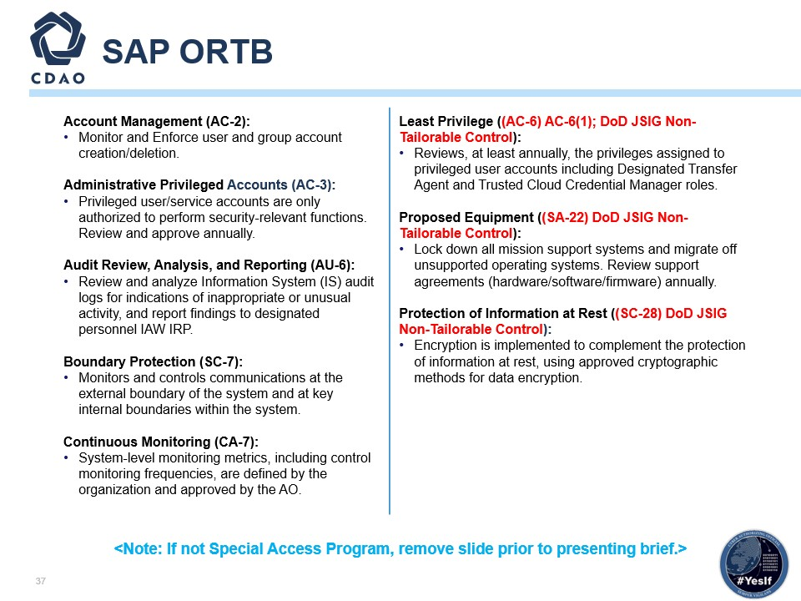

- Defer to Department of Defense (DoD) Joint Special Access Program (SAP) Implementation Guide (JSIG), 11 April 2016.​
- Cyber hygiene describes recommended mitigations for the small number of root causes responsible for many cybersecurity incidents. Implementing a few simple practices can address these common root causes. ​
- The final determination of the appropriate set of risk areas supported by the risk mitigations is necessary to harden the IS, and the environment in which those systems operate is a function of the assessment of risk and what is required to sufficiently mitigate the risks to the overall operations and assets, individuals, other organizations, and the Nation. In many cases, additional areas or enhancements will be required to address specific threats to and vulnerabilities in your organizations, mission/business processes, and/or information systems and to satisfy the requirements of applicable federal laws, Executive Orders, directives, policies, standards, or regulations. The risk assessment in the risk mitigation process provides essential information in determining the necessity and sufficiency of the risk areas and enhancements in the initial baselines. ​
  - AC-2; Account Management - Information System (IS) account types are defined by the organization, and supporting mission and business functions are clearly defined.​
  - AC-4; Information Flow Enforcement - The organization ensures that the information system enforces approved authorizations for controlling the flow of information within the system and between interconnected systems.​
  - AC-5; Separation of Duties - Obtains and examines the documented duties to ensure the organization defines the duties of individuals that are to be separated.​
  - AC-6; Least Privilege - The organization obtains and examines the documented processes to ensure that the organization implements the concept of least privilege, allowing only authorized accesses for users (and processes acting on behalf of users) which are necessary to accomplish assigned tasks in accordance with organizational missions and business functions.​
    - LEAST PRIVILEGE | REVIEW OF USER PRIVILEGES The organization: (a) Reviews at least annually the privileges assigned to privileged user accounts, including DTA role to validate the need for such privileges; and (b) Reassigns or removes privileges, if necessary, to correctly reflect organizational mission/business needs. ​
    - AC-6(1), Enhancement for Least Privilege needs to be addressed.​
  - AU-6; Audit Review, Analysis, and Reporting - The organization defines the frequency for the review and analysis of information system audit records for organization-defined inappropriate or unusual activity.​
  - SC-7; Boundary Protection - Obtains and examines network topology diagrams, architecture documentation, or any other documentation identifying component partitioning to ensure the organization implements subnetworks for publicly accessible system components that are physically and/or logically separated from internal organizational networks.​
  - CM-6; Configuration Settings - Obtains and examines the documented process to ensure the organization monitors changes to the configuration settings in accordance with organizational policies and procedures.​
  - RA-5; Vulnerability Scanning - Obtains and examines the contracts/agreements to ensure the organization requires that the developer provide administrator documentation for the information system, system component or information system service that describe secure configuration of the system, component, or service.​
  - SA-22, Unsupported System Components - Replaces information system components when support for the components is no longer available from the developer, vendor, or manufacturer; and provides justification and documents approval for the continued use of unsupported system components required to satisfy mission and business needs.​
  - SC-28, Protection of Information at Rest - Obtains and examines the documented information at rest to ensure the organization defines and documents the information at rest that is to be protected by the information system which must include, at a minimum, PII and classified information.

SAP ORTB (Continued)
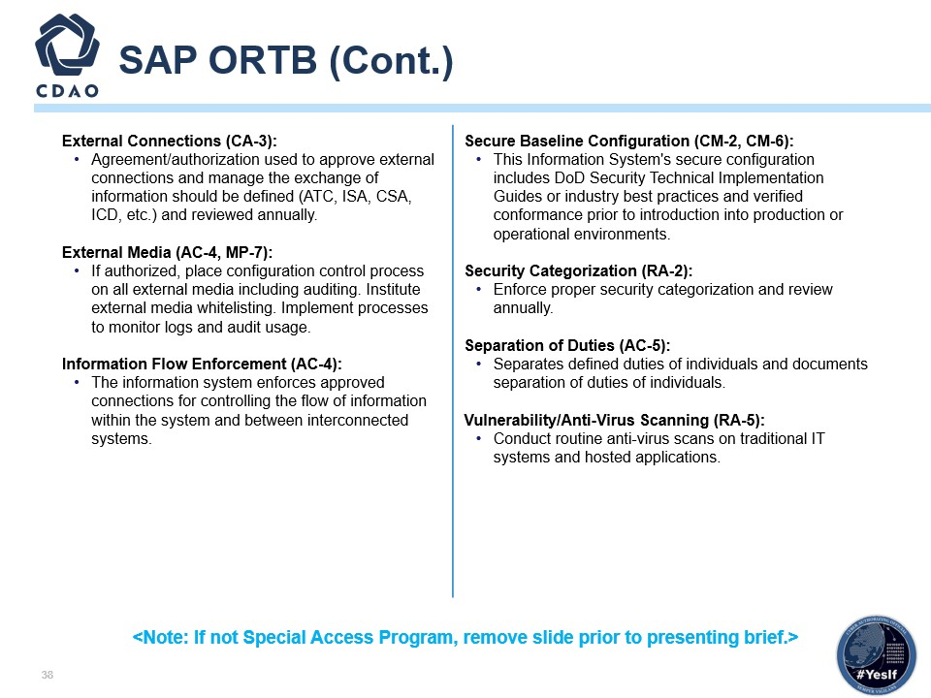

- Defer to Department of Defense (DoD) Joint Special Access Program (SAP) Implementation Guide (JSIG), 11 April 2016.​
- Cyber hygiene describes recommended mitigations for the small number of root causes responsible for many cybersecurity incidents. Implementing a few simple practices can address these common root causes.
- The final determination of the appropriate set of risk areas supported by the risk mitigations is necessary to harden the IS, and the environment in which those systems operate is a function of the assessment of risk and what is required to sufficiently mitigate the risks to the overall operations and assets, individuals, other organizations, and the Nation. In many cases, additional areas or enhancements will be required to address specific threats to and vulnerabilities in your organizations, mission/business processes, and/or information systems and to satisfy the requirements of applicable federal laws, Executive Orders, directives, policies, standards, or regulations. The risk assessment in the risk mitigation process provides essential information in determining the necessity and sufficiency of the risk areas and enhancements in the initial baselines. ​
  - AC-2; Account Management - Information System (IS) account types are defined by the organization and supporting mission and business functions are clearly defined.​
  - AC-4; Information Flow Enforcement - The organization ensures that the information system enforces approved authorizations for controlling the flow of information within the system and between interconnected systems.​
  - AC-5; Separation of Duties - Obtains and examines the documented duties to ensure the organization defines the duties of individuals that are to be separated.​
  - AC-6; Least Privilege - The organization obtains and examines the documented processes to ensure that the organization implements the concept of least privilege, allowing only authorized accesses for users (and processes acting on behalf of users) which are necessary to accomplish assigned tasks in accordance with organizational missions and business functions.​
    - LEAST PRIVILEGE | REVIEW OF USER PRIVILEGES The organization: (a) Reviews at least annually the privileges assigned to privileged user accounts, including DTA role to validate the need for such privileges; and (b) Reassigns or removes privileges, if necessary, to correctly reflect organizational mission/business needs. ​
    - AC-6(1), Enhancement for Least Privilege needs to be addressed.​
  - AU-6; Audit Review, Analysis, and Reporting - The organization defines the frequency for the review and analysis of information system audit records for organization-defined inappropriate or unusual activity.​
  - SC-7; Boundary Protection - Obtains and examines network topology diagrams, architecture documentation, or any other documentation identifying component partitioning to ensure the organization implements subnetworks for publicly accessible system components that are physically and/or logically separated from internal organizational networks.​
  - CM-6; Configuration Settings - Obtains and examines the documented process to ensure the organization monitors changes to the configuration settings in accordance with organizational policies and procedures.​
  - RA-5; Vulnerability Scanning - Obtains and examines the contracts/agreements to ensure the organization requires that the developer provide administrator documentation for the information system, system component or information system service that describe secure configuration of the system, component, or service.​
  - SA-22, Unsupported System Components - Replaces information system components when support for the components is no longer available from the developer, vendor, or manufacturer; and provides justification and documents approval for the continued use of unsupported system components required to satisfy mission and business needs.​
  - SC-28, Protection of Information at Rest - Obtains and examines the documented information at rest to ensure the organization defines and documents the information at rest that is to be protected by the information system which must include, at a minimum, PII and classified information.​

Additional DAF Back-Up Slides

eMASS Guidance AFI 17-101
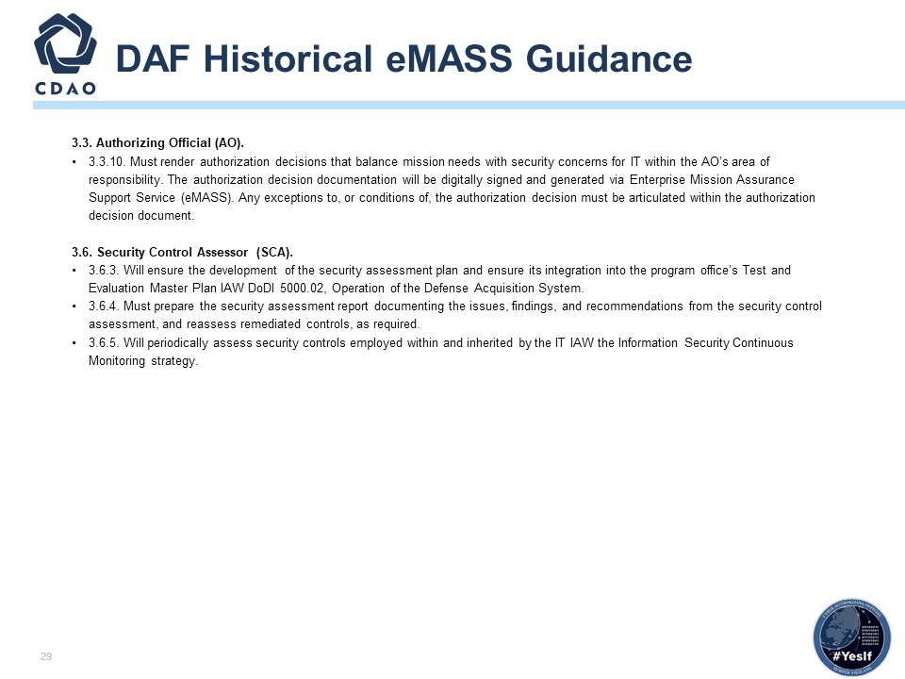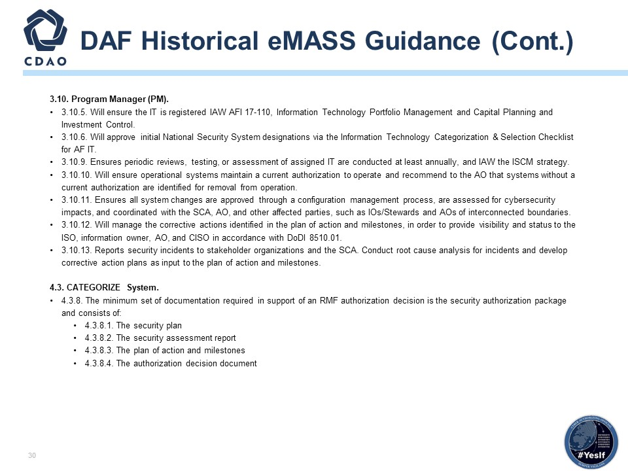

OVL AO eMASS Guidance
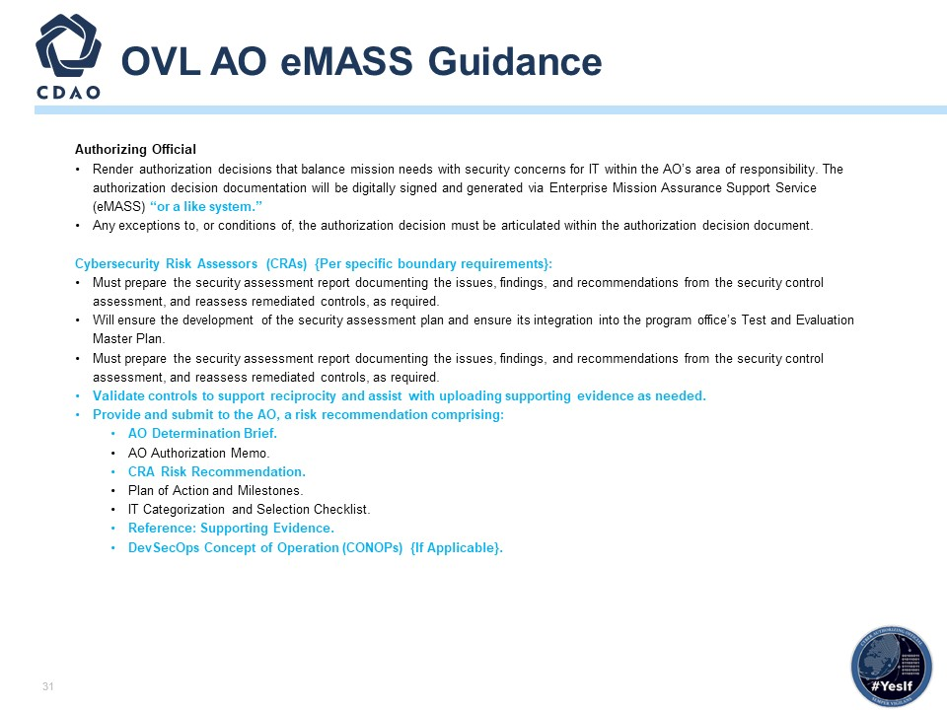
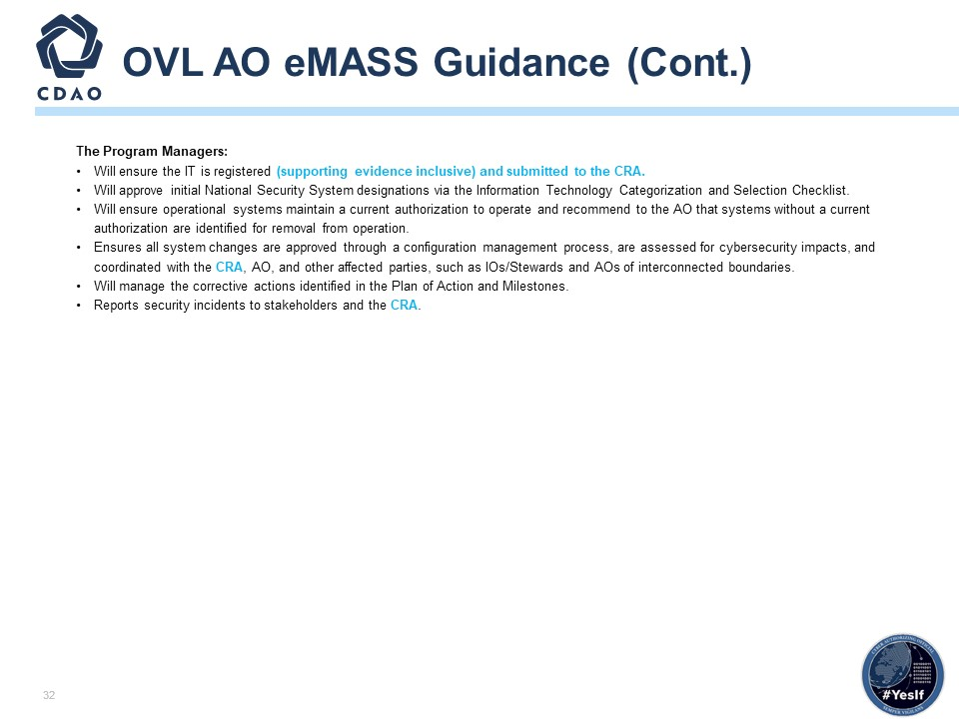

Authorization Package
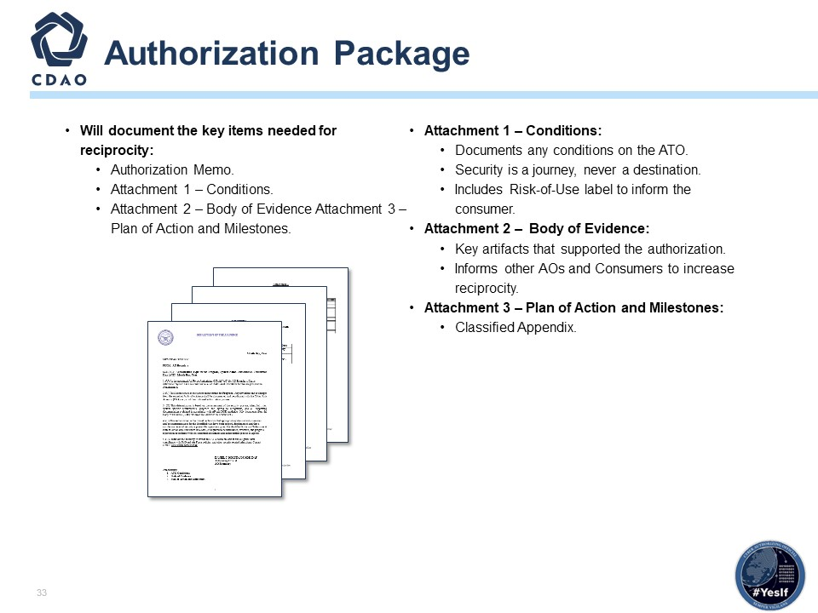

Authorization Determination Table
